Constructors
Constructors can be defined as special methods which are meant to perform special operations.
  - Rules to create a constructors
- Constructor name should be same as class name.
- Constructors can accept arguments.
- Constructors do not have return type.

To execute a constructor, we need to create an object.
Constructors can be categorized into three types
- Default constructor
- Zero Argument constructor
- Parameterized constructor
When exactly are constructors executed?
They are executed during object creation.
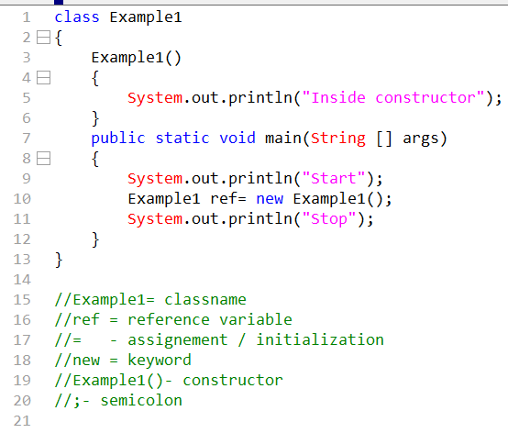
- The constructors at any point of time cannot return any data but can only return the controller.
- Hence constructors can only support return statement as it only returns the control If we do not add return statement then the compiler by default will add return statement. //by default it will add at end.
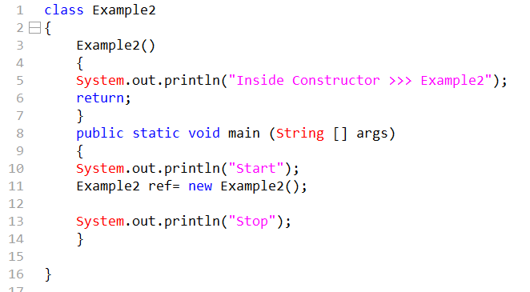

- The Javap command will display all the members within the class after the compilation.
- If we do not create any constructor then the compiler will create a zero argument, empty implementation default constructor
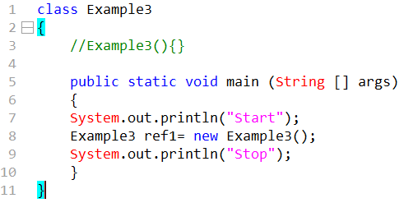
- Constructors are never ever part of heap area and neither stored in the heap area but constructors are always executed in the stack area.
- Constructors can only be called during object creation.
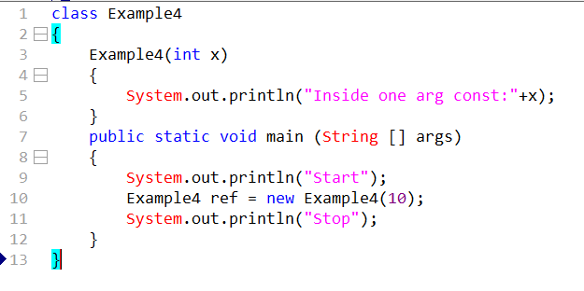

Q. How many times will constructor get executed?
Number of times we create an object or we use new keyword that many times constructor will get executed.
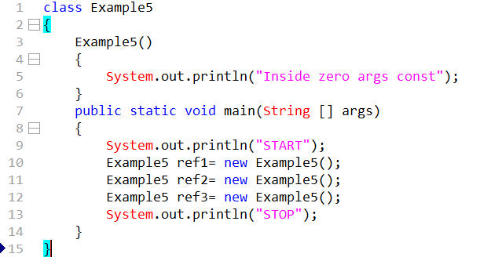

- In a java class we can create minimum one constructor or we can create multiple constructors.
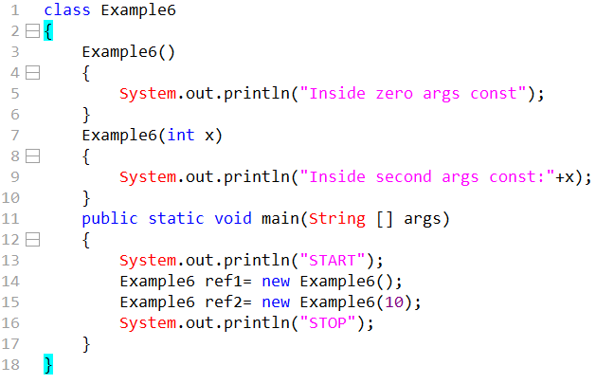
- If we do not create any constructor only then compiler will create a zero argument. Default empty implementation constructor but if we create some constructor then the compiler will never create a zero-argument empty implementation default constructor.
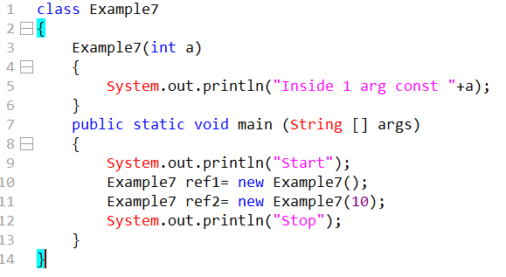

- Duplicate constructors are not allowed in java
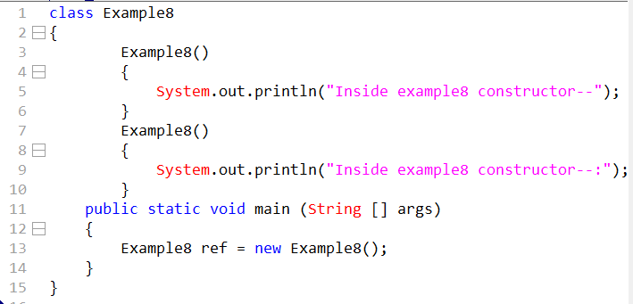
What is the real time purpose of the constructors?
Constructors are primarily used for two purposes in real time
- It is meant to initialize the non-static members during the object creation.
- It is meant to implement business logic during object creation.
//Example9 implementation of point 1
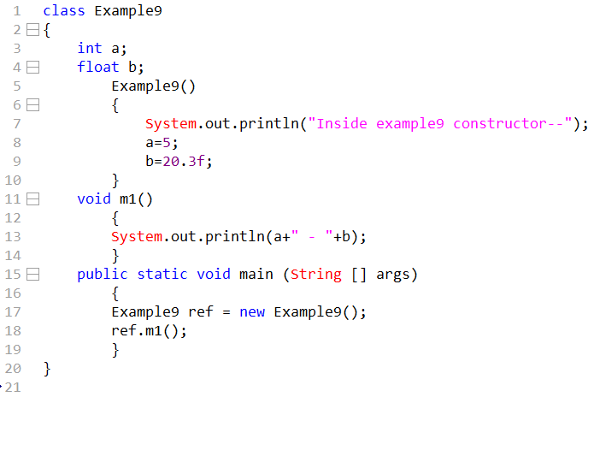
In real-time we always maintain business logics in separate class, we always main method in controller class.
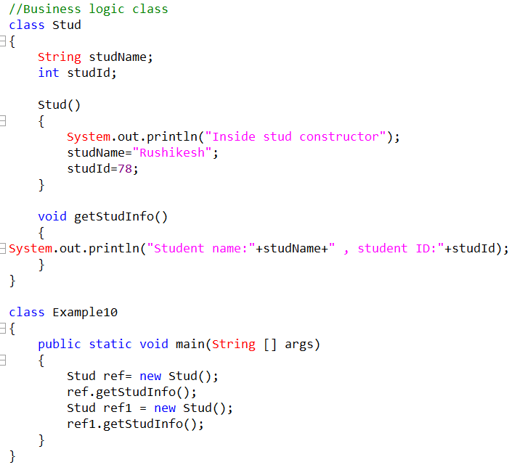
- Example10 is problem using this particular logic.
- If we initialize using example10 logic then number of student will have same ID.
- In real time we always maintain business class in separate class and we always maintain main method inside the controller class.

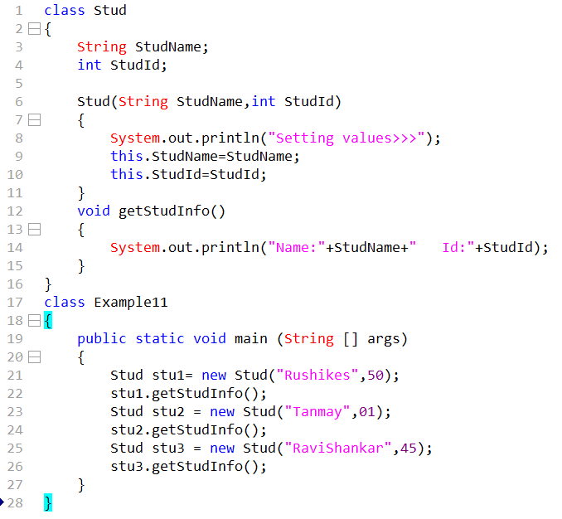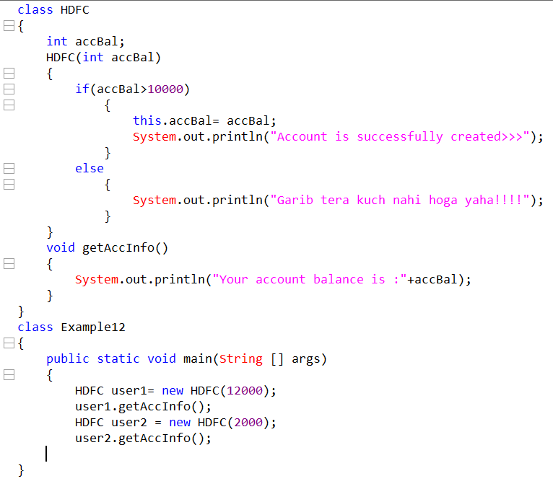
This statement is made to call another constructor within same class
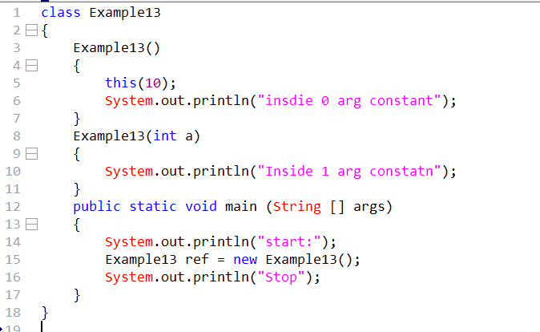

This >> keyword>> Stores /holds the current object address
This()>>Method/statement >>to call another constructor within same class.
The this statement should always be the first statement within the constructor.
Difference between Classes and Objects?
Class | Object
- Class is a set of characteristics or design or plan.  - Classes do not consume RAM memory.  - Classes don’t depend on Objects.  - We minimum require one class in a java program.  - Class keyword is used while creating new class. | - Implementation of plan or design or characteristics is called as object.  - Objects consume RAM memory.  - Object depends on class.  - From once class we can create one object.  - New keyword is required to  create new object.

This statement is used to call another constructor within same class.
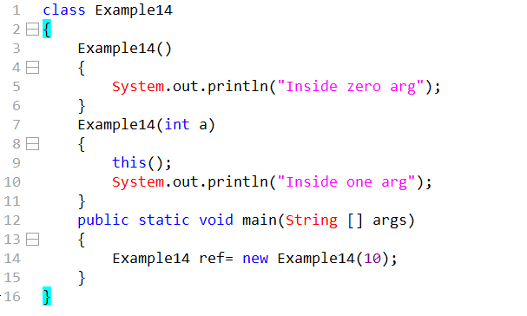
The this statement should always be the first statement within the constructor.
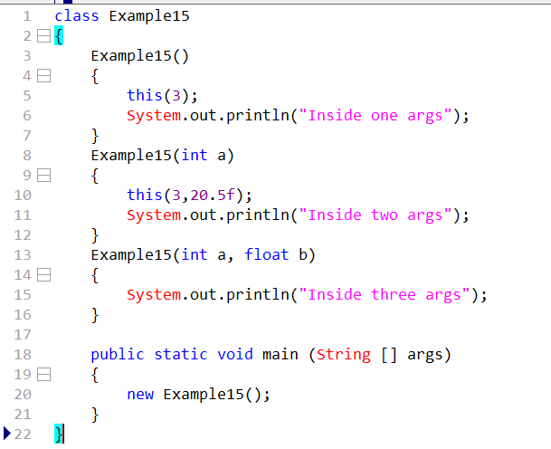
Recursive constructor’s calls are not supported by java.
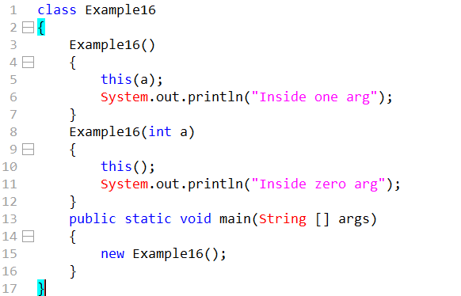
We cannot use more than one this statement within a constructor.

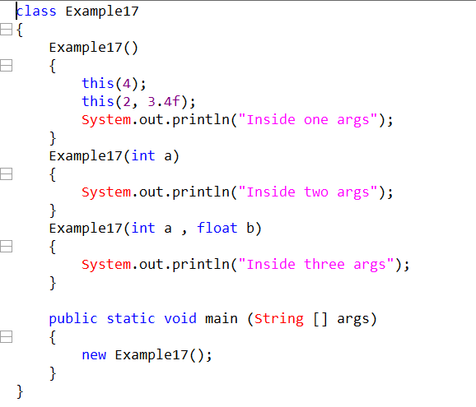

- This statement and this keyword can be used only within the constructor.
- This keyword can be used within the method.
- This statement cannot be used within the method.
- This statement should be always written at first statement within the constructor but this keyword can be written anywhere.
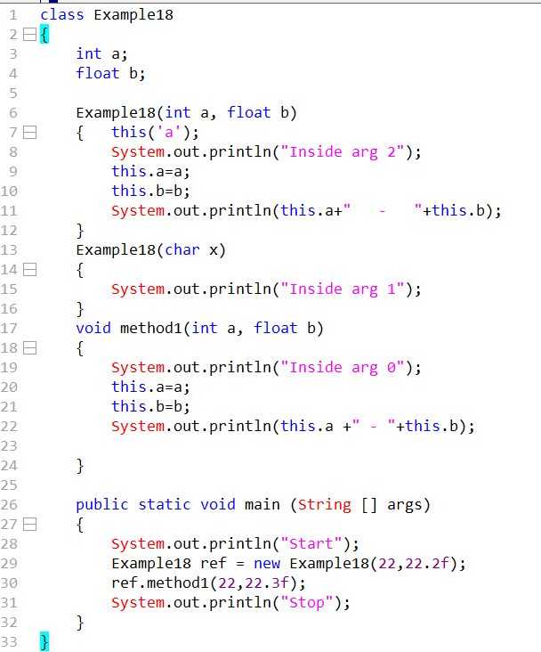
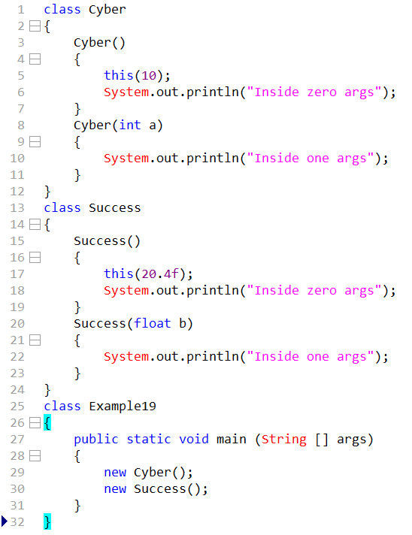

Non-static blocks / Instance block
The block of code which is declared outside the main method without any prefix is called as non-static or instance block.

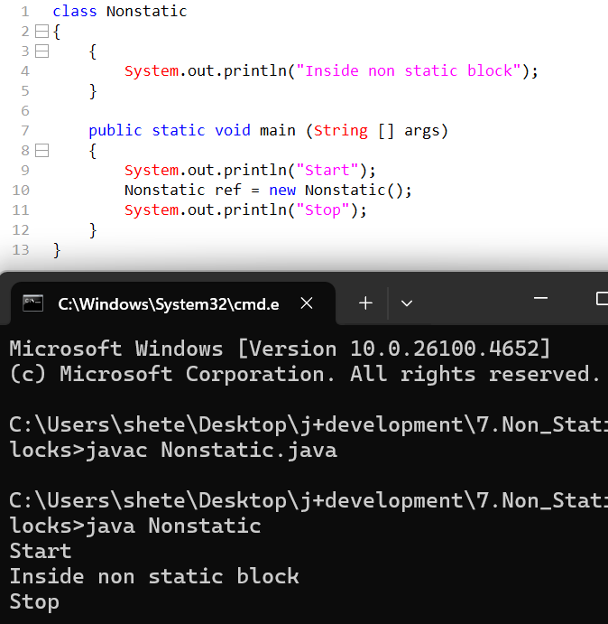

- When exactly are Non-Static blocks are executed.
They are executed during object creation.
- During Object creation which one will get executed constructor or instance block?
Both will get executed.
- During object creation out of instance block or constructor which one will get executed.
First instance block will get executed then constructor will get executed.
Working of Instance Block
During object creation after the new keyword is used the control will be given to the constructor, before constructor starts the execution it will check for non-static blocks whether the non-static blocks are present within the specific class, If blocks are present then the non-static block will get executed first then constructor and if non static block is not present then constructor will get executed directly.

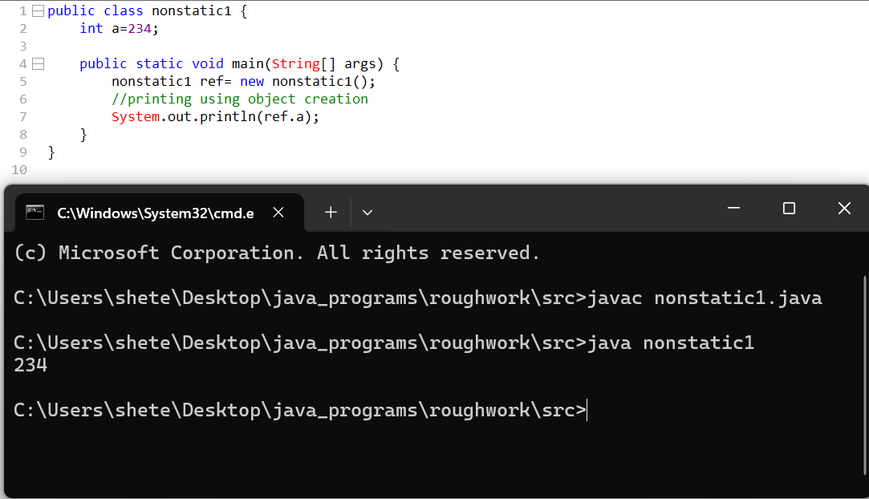

- We can create minimum one instance block or we can create multiple instance blocks.
- The order of execution of instance block will be from top to bottom.
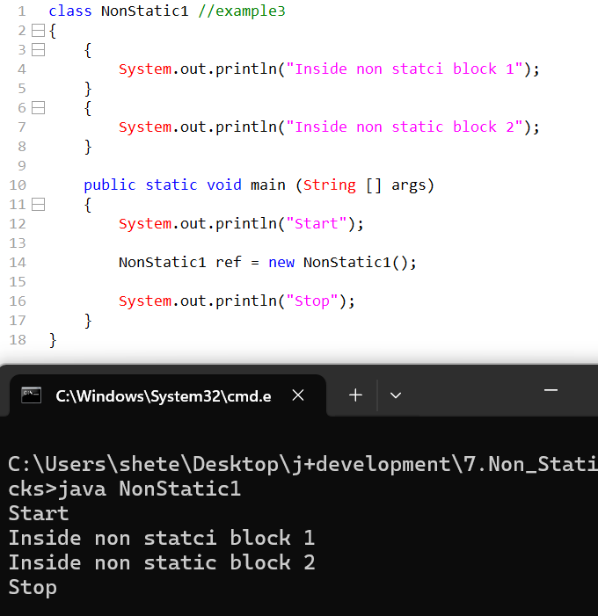

How many times will an instance block get executed?
- Based on number of times we use new keyword or number of times we create an object.
- Instance blocks are only called during object creation.
- It is possible to invoke constructor or instance block from another class.
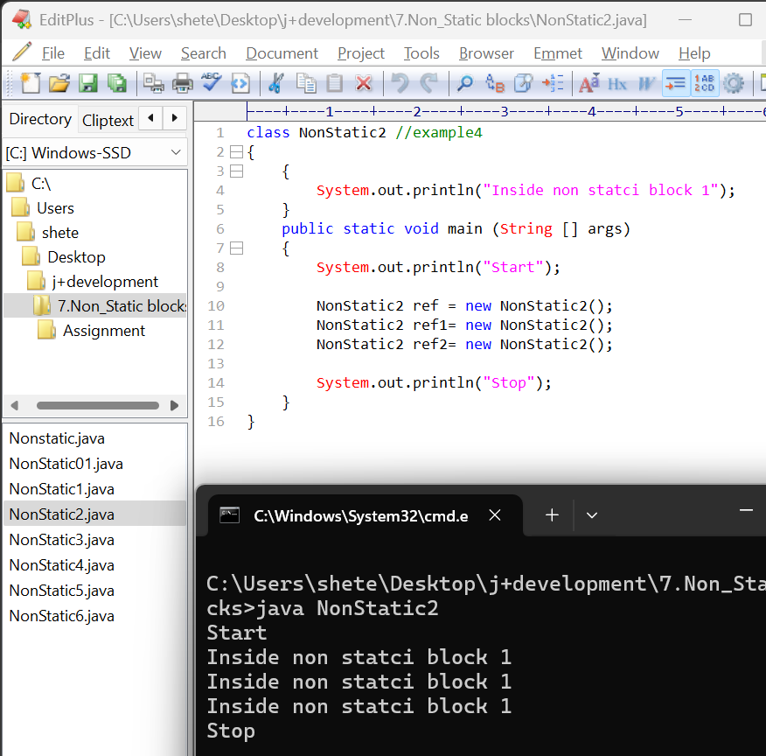

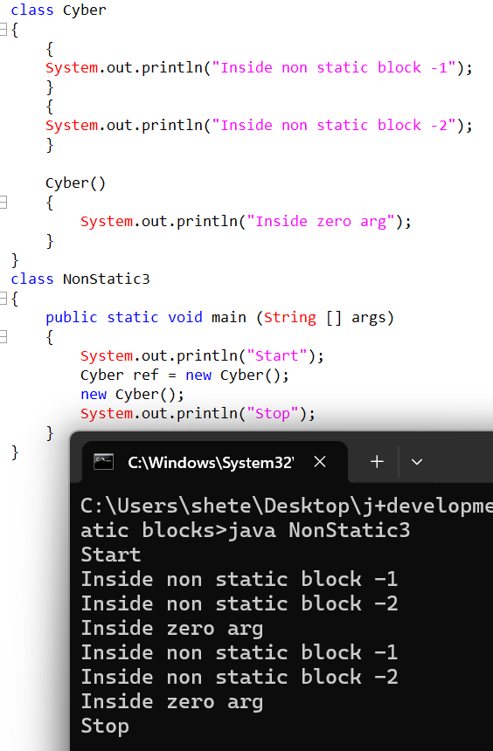
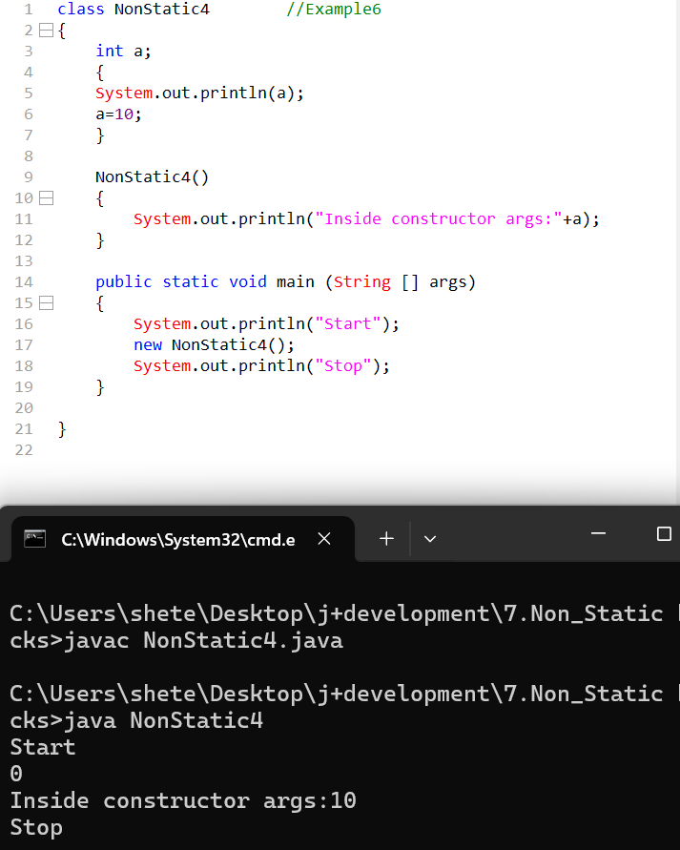

What is the primary purpose or real time purpose of using instance block?
Instance blocks are primarily used for two purposes
- To initialize non static variables during object creation.
- To implement the business logic during the object creation.

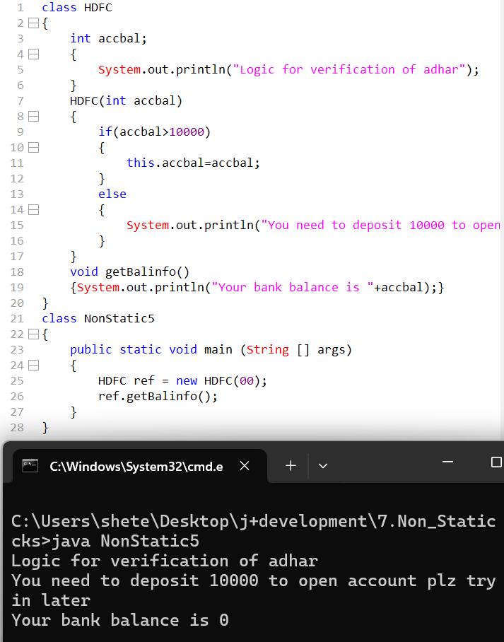
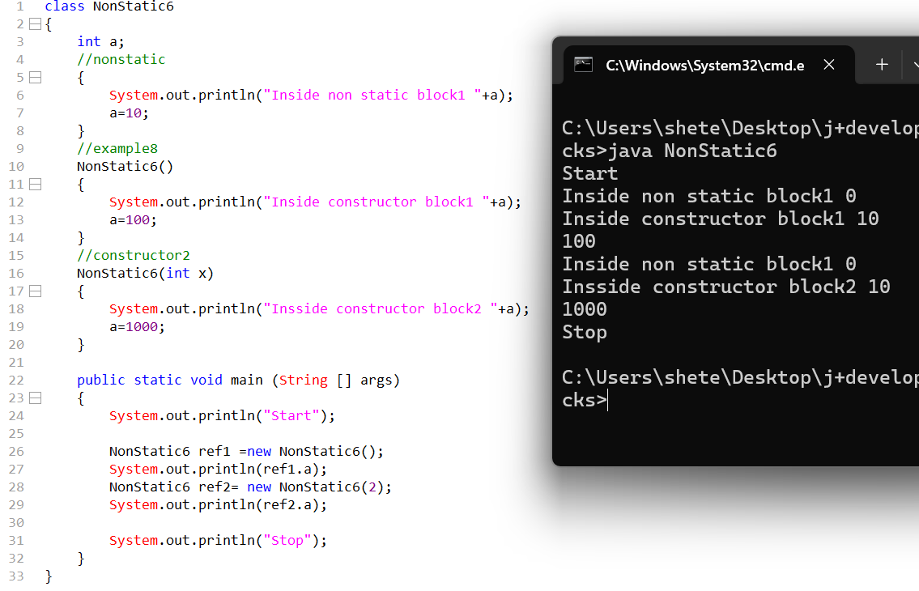

When constructors and instance block perform the same operation then what is the difference between constructors and instance blocks?
Instance block logics are applicable to all constructors as well as all objects whereas constructor’s logics are applicable to the respective constructor and respective object.

Static Blocks
Syntax:
static
{
Statements;
}

- Static blocks are executed during the class loading time.
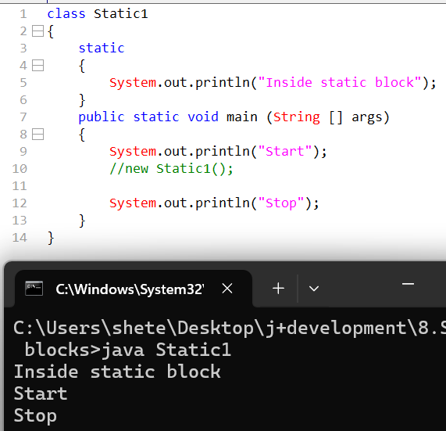

Q. What is the output of the following code?
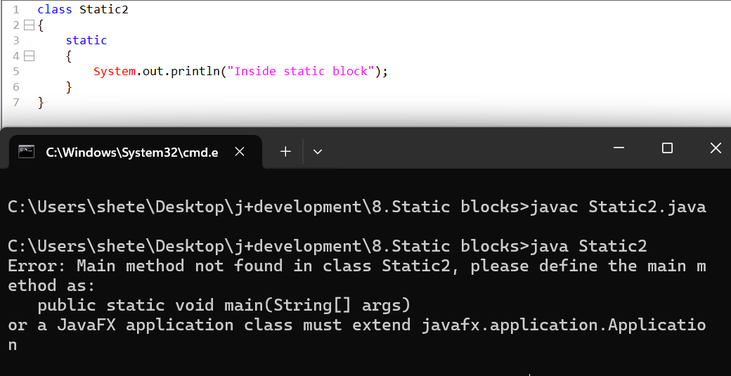
This code will compile but it will not execute
- If the same code were run on java 1.7 it will get executed,
- If a same code were run on java 1.8 it will not get executed.
- In 1.8 version onwards it is made mandatory that main is required to represent for execution.

In a java class we can have one static block or we can have multiple static blocks, whenever there are multiple static blocks the execution order of these blocks is found top to bottom.
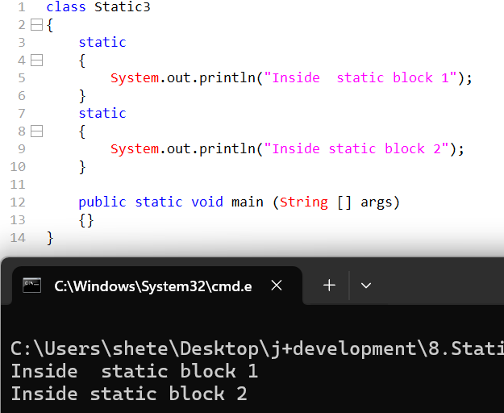

- If static blocks are part of another class those blocks will only get executed when jvm loads the other class in the memory.
- When the other class are loaded class loader will be import and based on which static blocks will get executed.

//STATIC 4

Static members will load only once but non static members are loaded multiple times based on object creation.
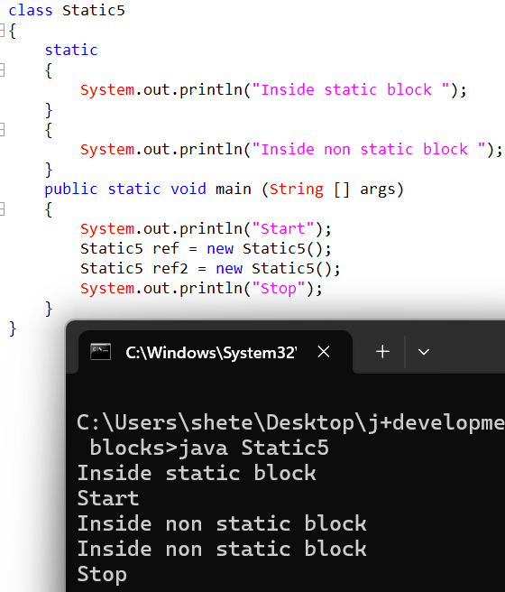
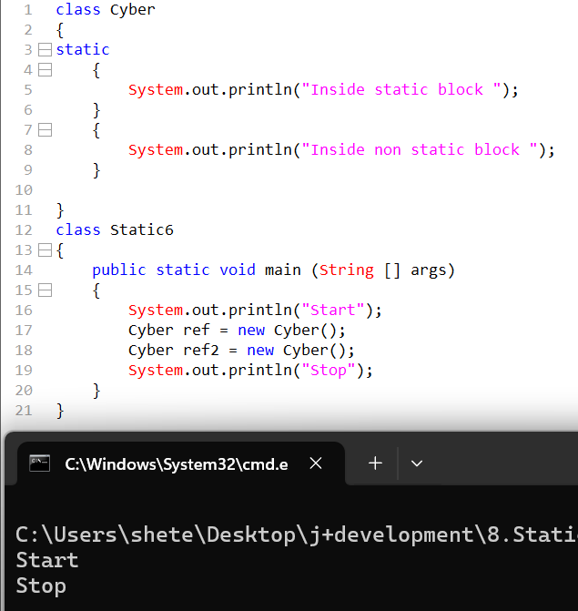

What is the main purpose of the static blocks? why exactly we use static blocks?
- To initialize the static members during the class loading.
- To implement the business logics during the class creation.
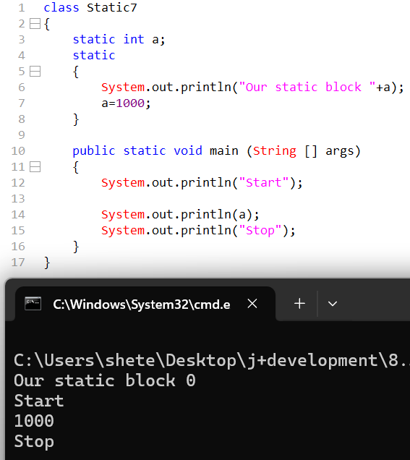

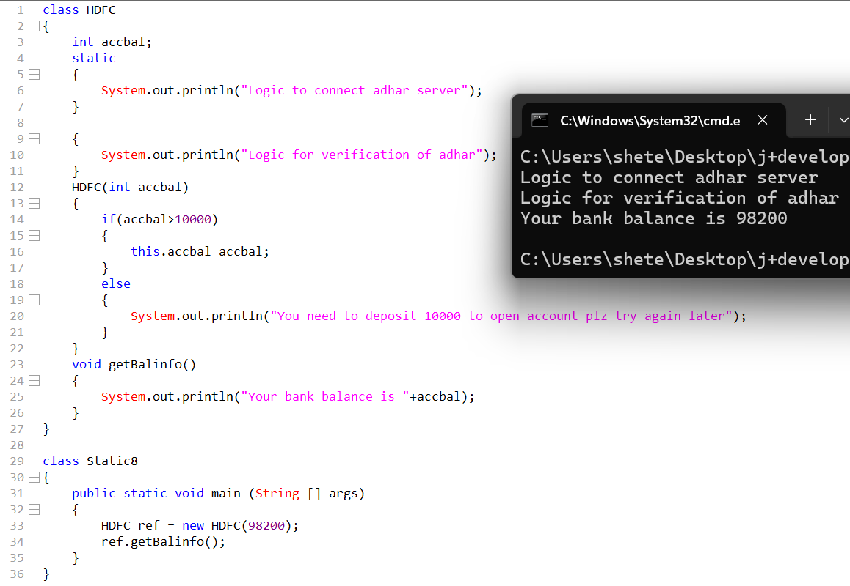

- In constructor -> check if we can create an object
- In constructor -> check if we can call a method
- In constructor -> initialize static members.
- In non static blocks > check if we can create an object(same class /another class)
- In non static blocks> check if we can call a method
- In nonstatic blocks > initialize static members.

• In constructor → create an object
✅ Yes, you can create an object (of the same class or another class).
- In constructor → call a method
✅ Yes, you can call methods (both instance and static).
- In constructor → initialize static members
❌ No, static members should be initialized in static blocks or at declaration, not inside constructors.
- In non-static blocks → create an object (same class/another class)
✅ Yes, you can create objects inside non-static (instance) blocks.
- In non-static blocks → call a method
✅ Yes, you can call methods (both instance and static).
- In non-static blocks → initialize static members
❌ No, static members cannot be initialized in non-static blocks. They must be initialized in static blocks or at declaration.

https://chatgpt.com/share/694ed077-98f4-8008-bbba-d929bdce74e8

- What are the constructors?
Constructors can be defined as special methods which are meant to perform special operations.
EXAMPLE>>>
Final seating / customer details
Things done per person based on details:
- Assign seat type
- Print ticket with name

- In java When we create a new class by default internally it will create zero argument empty implementation default constructor what is the purpose behind that?
The default constructor exists to enable object creation, initialize instance variables with default values, support inheritance via super().
- What is the real time purpose of the constructors?
Constructors are primarily used for two purposes in real time
1.It is meant to initialize non-static members during the object creation.
2.It is meant to implement business logic during object creation.
- What is the difference between this keyword and this statement?
This >> keyword>> Stores /holds the current object address
This ()>>Method/statement >>to call another constructor within same class.
- What is the Difference between class and object?
Class | Object
- Class is a set of characteristics or design or plan.  - Classes do not consume RAM memory.  - Classes don’t depend on Objects.  - We minimum require one class in a java program.  - Class keyword is used while creating new class. | - Implementation of plan or design or characteristics is called as object.  - Objects consume RAM memory.  - Object depends on class.  - From once class we can create one object.  - New keyword is required to  create new object.

- Why recursive constructor calls are not supported in java?
Java does not support recursive constructor calls because constructors must initialize an object exactly once, and recursion would cause infinite object creation, improper initialization, and memory failure.
- Can we use multiple this statements in java? why?
No, Java does not allow multiple this() statements because this() must be the first statement in a constructor, and allowing multiple calls would cause recursive initialization and break object consistency
- When constructors and instance block perform the same operation then what is the difference between constructors and instance blocks?
Instance block logics are applicable to all constructors as well as all objects whereas constructor’s logics are applicable to the respective constructor and respective object.
- What are Non-Static Blocks?
The block of code which is declared outside the main method without any prefix is called as non-static or instance block.

- When exactly are non-static blocks are executed.
They are executed during object creation.

- During Object creation which one will get executed constructor or instance block?
Both will get executed.
- During object creation out of instance block or constructor which one will get executed.
First instance block will get executed then constructor will get executed.
If static blocks are part of another class those blocks will only get executed when JVM loads the other class in the memory.
Static members will load only once but non static members are loaded multiple times based on object creation.
- What are the Static blocks?
Static blocks are used for one-time class-level initialization and execute once when the class is loaded into memory.
- What is the main purpose of the static blocks? why exactly we use static blocks?
Static blocks are used to perform one-time, class-level initialization before any object is created or main() is executed.
EXAMPLE>>>
Theatre setup (once)
Things done one time when the theatre opens:
- Power connection
- Projector setup
- License verification

